BADMINTON SWING ANALYZER USING MPU6050

MINI-PROJECT REPORT

Submitted by

ASWIN RAAJ R | (Reg.no: 202302011)
MANI BALAJI S | (Reg.no: 202302056)
THARUN VS | (Reg.no: 202302108)

In partial fulfilment for the award of the degree of

BACHELOR OF ENGINEERING IN

ELECTRICAL AND ELECTRONICS ENGINEERING



 | ,  MEPCO SCHLENK ENGINEERING COLLEGE, SIVAKASI  (An Autonomous Institution affiliated to Anna University Chennai)

NOVEMBER 2025

BONAFIDE CERTIFICATE

Certified that this project report titled “BADMINTON SWING ANALYZER USING MPU6050 “is the bonafide work of Mr.R.ASWIN RAAJ (REG.No:9517202302011), Mr.S.MANI BALAJI (REG.NO:9517202302056) and Mr.V.S.THARUN (REG.NO:9517202302108 ) who carried out the mini-project under my supervision. Certified further, that to the best of my knowledge the work reported herein does not form part of any other project report or dissertation on the basis of which a degree or award was conferred on an earlier occasion on this or any other candidate.

Dr.G.Pandiaraj, M.E., Ph.D. Dr. N. Senthil Kumar, M.E., Ph.D.

Supervisor Head of the Department
Assistant Professor, (Sl.Grade) Senior Professor,
Department of Electrical and Electronics Department of Electrical and Electronics Engineering, Engineering,
Mepco Schlenk Engineering College, Mepco Schlenk Engineering College,
Sivakasi. Sivakasi.

Submitted for Viva-Voce Examination held at MEPCO SCHLENK ENGINEERING COLLEGE, SIVAKASI (AUTONOMOUS) on ……………..............

Examiner 1 | Examiner 2

ABSTRACT
- The Badminton Swing Analyzer using the MPU6050 is a compact, low-cost, and portable system designed to capture, analyse, and evaluate the motion of a player’s racket during gameplay and training sessions.
- The MPU6050 sensor, which integrates a 3-axis accelerometer and 3-axis gyroscope, is mounted on the racket handle or the player’s wrist to record high-frequency inertial measurements, including linear acceleration and angular velocity along all three axes.
- These signals are acquired in real time through a microcontroller equipped with wireless communication, such as an ESP32 and are transmitted to a processing unit for analysis. The raw sensor data undergoes calibration and noise filtering to correct for drift, bias, and unwanted vibrations, followed by gravity compensation and sensor fusion techniques such as Kalman filtering to determine motion profiles accurately.
- The proposed solution emphasizes affordability, portability, and ease of integration, making it suitable for amateur players seeking self-analysis as well as for professional coaching environments where objective, data-driven insights can complement traditional observational methods.
ACKNOWLEDGEMENT

An endeavour over a long period can be successful only with the advice and support of many well-wishers. First and foremost, we thank the lord almighty for his abundant grace and blessings for marking this work a great success.

We would like to extend our sincere gratitude to our honourable Principal Dr.S.ARIVAZHAGAN, M.E., Ph.D., FIETE. MISTE for providing ample facilities and necessary infrastructure during the course of the project.

We express our regards and thanks to our great support Dr.N.SENTHIL KUMAR,M.E., Ph.D., Senior Professor and Head of Electrical and Electronics Engineering Department for his cordial encouragement throughout the project.

We take great pleasure in expressing our deep sense of gratitude to
Dr.G.PANDIARAJ, M.E., PhD for his excellent guidance, encouragement and personal interest throughout the course of the project. Without his encouragement and guidance, this project would not have been materialized.

We also thank all the staff members and lab technicians of Electrical and Electronics Engineering Department for their kind co-operation in the completion of the project.
Finally, we express our gratitude to our family and friends for their invaluable assistance throughout this project.

TABLE OF CONTENTS

S.No | Contents | Page.no
1. | Chapter 1: INTRODUCTION | 1
2. | Chapter 2: LITERATURE REVIEW | 4
3. | Chapter 3: PROJECT REQUIREMENTS | 6
4. | Chapter 4: SYSTEM DESIGN | 9
5. | Chapter 5: IMPLEMENTATION | 12
6. | Chapter 6: RESULTS | 16
7. | CONCLUSION | 17
8. | REFERENCES | 18

TABLE OF FIGURES

S.No | Figure No. | Figure name | Page No.
 | 3.1 | MPU6050 | 6
 | 3.2 | ESP32 Dev Kit V1 | 6
 | 3.3 | Push Button | 6
 | 3.4 | 3.7v Li-Po 1000mAh Battery | 6
 | 3.5 | TP4056 Charging Module | 7
 | 3.6 | Badminton Racket | 7
 | 4.1 | Block diagram of Badminton Swing Analyzer MPU6050 | 9
 | 5.1 | Prototype Design | 15
 | 5.2 | Badminton Swing Analyzer using MPU6050 - Prototype | 15

CHAPTER 1
INTRODUCTION
1.1 Background
Badminton is one of the most popular sports that depends heavily on precision, timing, and technique. During regular practice, players often struggle to understand whether their swing speed, wrist rotation, or racket angle is correct. Traditional coaching methods mostly rely on visual observation, which cannot accurately capture the small changes in motion or provide real-time quantitative feedback.
This inspired us to design a system that could measure, analyse, and visualize the player’s swing using affordable and compact electronic components. I selected the MPU6050 sensor because it combines both a 3-axis accelerometer and a 3-axis gyroscope, allowing the system to measure both linear acceleration and angular velocity in real time. Its small size, high precision, and ease of interfacing made it ideal for mounting on a badminton racket.
The ESP32 microcontroller was chosen due to its built-in Wi-Fi capabilities, low power consumption, and ability to handle real-time data processing and cloud communication. The idea was to make the system wireless, so players could view their swing data instantly without cables.
Before starting the design, we studied a few existing works, such as smartphone-based motion trackers and wearable IMUs used in cricket and tennis analytics. However, I found that there was very limited research or implementation specifically for badminton swing analysis. Hence, my goal was to develop a low-cost, portable, and practical system that could bridge this gap and bring motion analytics to badminton training.

1.2 Objective
The main objective of the project was to design a compact and efficient badminton swing analyser capable of capturing and analysing the motion parameters of a player’s swing. The system aims to measure linear acceleration, angular velocity, and orientation during every stroke.
Specific objectives include:
- To implement accurate motion sensing using the MPU6050 for detecting swings.
- To calibrate the sensor to remove bias and improve precision.
- To apply filtering algorithms (like complementary or Kalman filter) to combine accelerometer and gyroscope data and achieve stable orientation tracking.
- To create a low-cost, battery-powered prototype suitable for use in real badminton environments.

1.3 Significance
The Badminton Swing Analyzer project holds great significance because it brings scientific, data-driven analysis to a sport that is often evaluated by observation. It helps players understand their technique quantitatively, which is critical for improving speed, timing, and consistency.
For coaches, the system offers objective measurements that can validate player performance, reduce subjectivity, and assist in designing more effective training sessions. Real-time wireless feedback enables instant correction during practice, while data logging allows tracking of progress over time.
Its affordability makes it accessible to college athletes, training academies, and beginners, unlike high-end motion capture systems used in professional sports. The system’s portability ensures it can be used anywhere — indoor courts or outdoor environments — without complex setup.
From an engineering standpoint, this project demonstrates the practical use of embedded systems, MEMS sensors, and IoT in sports technology. It also opens doors for future improvements such as machine learning-based shot classification, mobile app integration, and AI-based performance prediction.
Overall, this project not only showcases technical innovation but also promotes the idea of blending electronics with sports science to create smarter, more efficient training systems.

CHAPTER 2
LITERATURE REVIEW

2.1 Behaviour of a Badminton player
Understanding the behaviour of a badminton player is essential for analysing performance and improving technique. The behaviour is reflected through playing style, shot execution, body coordination, and consistency during gameplay. Using the Badminton Swing Analyzer with MPU6050, we can capture and evaluate these behavioural parameters through the measurement of linear acceleration, angular velocity, and racket orientation.
By processing these readings, the system helps in identifying tendencies such as a player’s preference for aggressive smashes or defensive clears, reliance on wrist movement rather than full-arm swings, or improper timing during shuttle contact. It can also detect incomplete follow-through motions and variations in swing speed or acceleration. These insights reveal weaknesses or inconsistencies in a player’s form.
Through continuous monitoring, we can track improvement trends, allowing players to set measurable goals. With the integration of machine learning algorithms, stroke classification can be implemented to identify shot types automatically, such as smashes, drops, or drives. This enables personalized feedback and strategy adjustments against different opponents. Hence, disciplined practice combined with motion analytics can help players achieve greater consistency, accuracy, and control in their gameplay.
2.2 Technology Background
From a technological perspective, the Badminton Swing Analyzer is based on the use of motion-sensing and embedded system technologies to capture, analyse, and interpret physical movements. The MPU6050 is a compact MEMS sensor that combines a 3-axis accelerometer and a 3-axis gyroscope into a single chip. This combination allows the device to measure both linear acceleration and angular velocity simultaneously, providing a complete understanding of racket movement.
By mounting the sensor on the badminton racket, we can record detailed motion data during every swing. This data is processed by the ESP32 microcontroller, which acts as the system’s processing and communication hub. The ESP32 is chosen for its high-speed operation, low power consumption, and built-in Wi-Fi capability, enabling wireless data transmission to cloud platforms such as ThingSpeak for visualization and long-term analysis.
The data collected from the MPU6050 provides quantitative metrics about swing speed, racket angle, orientation, and stroke intensity. Through filtering algorithms such as Kalman or complementary filters, the raw data is refined to reduce noise and enhance accuracy. This ensures precise detection of even small variations in motion, which are critical for accurate analysis in fast-paced sports like badminton.
By combining advances in micro-electromechanical sensors, embedded programming, and cloud-based analytics, we have developed a system that represents the fusion of sports science and electronic engineering. This technological foundation not only supports badminton swing analysis but also serves as a scalable model for other sports where movement precision and technique optimization are essential.

CHAPTER 3
PROJECT REQUIREMENTS

3.1 Components Required
The components required for Badminton Swing Analyzer Using MPU6050 are Badminton Rocket,MPU6050,ESP32,TP4056 Charging Module ,3.7v Li-po battery, Connecting wires.
Components | Components
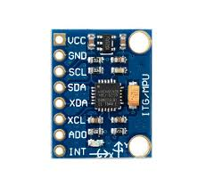  Fig 3.1 MPU6050 | 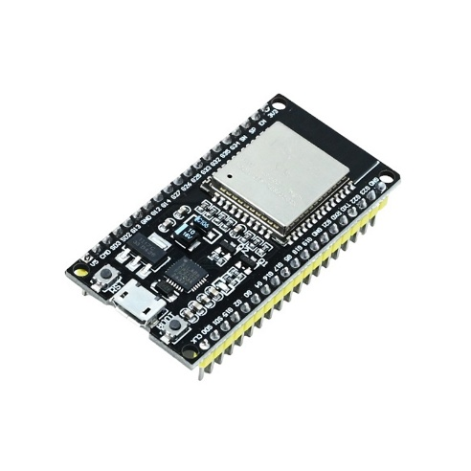  Fig 3.2 ESP32 Dev Kit V1
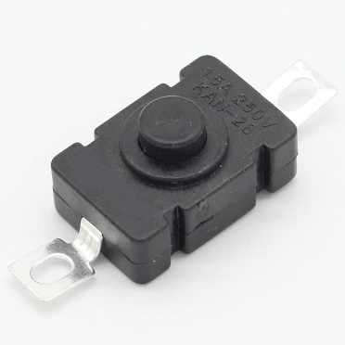  Fig 3.3 Push Button | 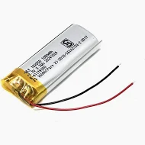  Fig 3.4. Li-po 3.7v 1000mah battery
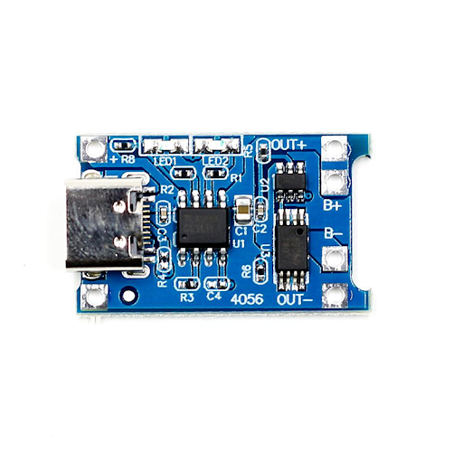  Fig 3.5 TP4056 Charging Module | 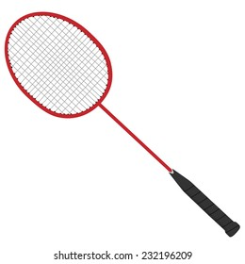  Fig 3.6 Badminton Racket.

3.2 Software Requirements
The software design defines the functional logic and data processing flow of the swing analyser. The entire programming was carried out in the Arduino IDE, chosen for its simplicity, compatibility with ESP32 boards, and extensive library support.
We utilized essential libraries including Wire.h for I2C communication with the MPU6050, WiFi.h and WebServer.h for network setup and communication, and MPU6050.h for sensor initialization and data reading. These libraries streamlined sensor data collection and processing while reducing code complexity.
To enhance the precision of sensor readings, we implemented a Kalman Filter algorithm. This filter effectively reduces noise and improves accuracy by combining accelerometer and gyroscope data, producing smoother and more reliable orientation estimates. Such filtering is crucial for motion analysis, where even small fluctuations can affect the interpretation of swing performance.
Instead of uploading data to cloud databases, we opted to store swing data locally in CSV format. This approach provides flexibility in offline analysis and simplifies data retrieval. The recorded data is visualized using Streamlit, Python, and MATLAB, enabling graphical representation of swing patterns, speed variations, and angular movements. This hybrid use of embedded coding and analytical tools provides a comprehensive environment for motion analysis and system performance evaluation.

4.3 Description of Components
The system setup requires a laptop or personal computer equipped with Wi-Fi connectivity and the Arduino IDE installed for programming, debugging, and serial data monitoring. The system operates efficiently on standard computing resources, and no high-end hardware is required.
For data visualization and analysis, the system supports Python-based environments with relevant data science libraries, as well as MATLAB for advanced signal and motion analysis. A stable Wi-Fi connection is recommended for seamless communication between the ESP32 and host computer.
The simplicity of these requirements ensures that the project remains portable and easily reproducible. The configuration provides an ideal balance between affordability, functionality, and analytical capability, making it suitable for both academic research and prototype development.

CHAPTER 4
SYSTEM DESIGN

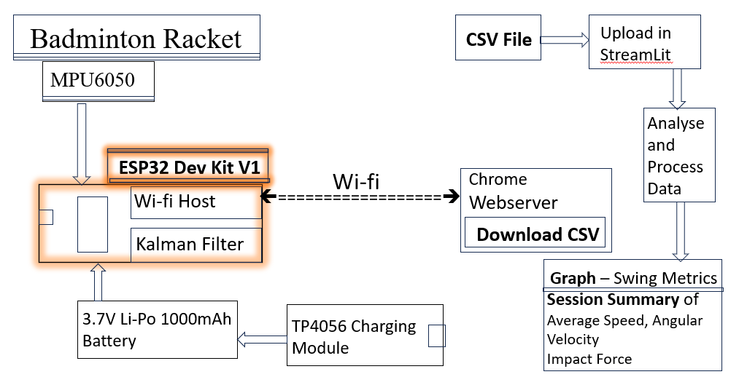
4.1 Block Diagram

Fig 4.1 Block diagram of Badminton Swing Analyzer Using MPU6050

4.2 Working Principle
When the system is powered on, the badminton swing analyser begins with an initial calibration phase. During this stage, the MPU6050 sensor remains stationary to determine the offset values of the accelerometer and gyroscope. These offsets are essential for compensating sensor drift and ensuring measurement stability.
Once calibration is complete, the ESP32 microcontroller establishes an I²C communication link with the MPU6050 to initiate real-time data acquisition. Both acceleration and gyroscopic readings are continuously collected to represent linear and rotational motion, respectively. These raw sensor outputs often contain noise and drift errors, which can significantly affect motion accuracy.
To overcome these issues, we employed an advanced sensor fusion technique using the Kalman Filter algorithm. This algorithm effectively combines the accelerometer and gyroscope data to produce accurate and smooth estimates of the racket’s angular orientation and movement. The Kalman filter corrects instantaneous measurement errors and predicts the optimal state of motion, ensuring high reliability even during rapid swings.
The processed data is transmitted in real time to a web server hosted by the ESP32. The server provides a simple user interface (UI) that allows the visualization of swing metrics such as angular velocity, acceleration peaks, and orientation changes. Through this interface, users can monitor live motion data during gameplay or practice sessions.
Additionally, the system offers a download option to store all recorded readings in CSV format. This dataset can be further analysed offline using Streamlit, Python, or MATLAB, enabling detailed visualization, signal plotting, and performance comparisons. By integrating embedded computation with web-based analytics, the system provides both instantaneous feedback and comprehensive data analysis, bridging the gap between hardware sensing and performance evaluation
4.3 Data Flow and Algorithm Explanation
The firmware of the Badminton Swing Analyzer follows a structured and cyclic operational sequence that ensures continuous monitoring and real-time performance tracking. The major steps in the algorithm are as follows:
- System_Initialization:
The ESP32 initializes all essential modules including serial communication, Wi-Fi setup, and I²C configuration. The MPU6050 sensor is powered on, and its registers are configured for full-scale range and sensitivity.
- Calibration_Phase:
The system reads a set of initial samples while the racket is kept stationary. These readings are averaged to determine the offset values for both accelerometer and gyroscope axes. These offsets are later subtracted from real-time data to reduce static errors.
- Data_Acquisition:
The ESP32 reads acceleration and angular velocity data from the MPU6050 sensor through I²C communication. The sampling rate is maintained at a stable frequency to ensure smooth data capture, typically in the range of several hundred samples per second.
- Filtering_and_Sensor_Fusion:
The collected raw data is processed using the Kalman Filter. This step reduces measurement noise and provides a more stable and accurate estimation of orientation and swing motion.
- Data_Transmission_and_Visualization:
The filtered and computed motion data is sent to the web server in real time. The user interface displays swing metrics dynamically, providing immediate insight into the player’s performance.
- Data_Logging:
All motion readings are stored in CSV format, which can later be downloaded for detailed offline analysis. This enables comparative studies across multiple sessions and helps in identifying performance trends.
- Continuous_Operation:
The process repeats continuously while the device is active, ensuring uninterrupted data monitoring during gameplay or practice.

CHAPTER 5
IMPLEMENTATION

5.1 Wiring and Setup
The hardware implementation of the Badminton Swing Analyzer is centred around the ESP32 microcontroller and the MPU6050 sensor module, which together form the core sensing and control unit. The circuit is designed to ensure stable power delivery, reliable communication, and compact integration for attachment on a badminton racket.
The ESP32 serves as the processing and communication hub of the system. It operates at 3.3V logic and is powered by a 3.7V, 1000mAh Li-ion battery, which provides sufficient energy for continuous operation. A voltage regulator onboard the ESP32 development board ensures consistent voltage supply to all internal components, protecting them from fluctuations or overcurrent conditions.
The MPU6050 sensor is interfaced with the ESP32 via the I²C communication protocol. The SDA (Serial Data) and SCL (Serial Clock) lines of the sensor are connected to the ESP32’s I²C pins, enabling synchronized transmission of sensor data. The sensor’s VCC pin is connected to the 3.3V output of the ESP32, while the GND pin is connected to the common system ground. Pull-up resistors are integrated within the board, ensuring stable communication without additional circuitry.
The circuit is enclosed in a compact tape-based mounting arrangement on the badminton racket, minimizing vibrations and preserving racket balance. This simple and lightweight assembly ensures the device remains unobtrusive during gameplay. The wiring layout is carefully routed to avoid strain or interference, with short I²C connections enhancing stability and reducing noise pickup.
5.2 Power Supply System
A 3.7V Li-ion polymer battery pack powers the system. The battery is chosen for its lightweight structure, rechargeability, and high energy density, making it ideal for portable sports applications. The ESP32’s onboard charging and voltage regulation circuitry ensure stable operation even as the battery voltage fluctuates.
During charging, a USB interface can be used without disconnecting the circuit, allowing convenient recharging through standard adapters or power banks. The overall current consumption of the setup remains below 250mA under full operation, ensuring extended runtime for multiple practice sessions on a single charge.
5.3 Code
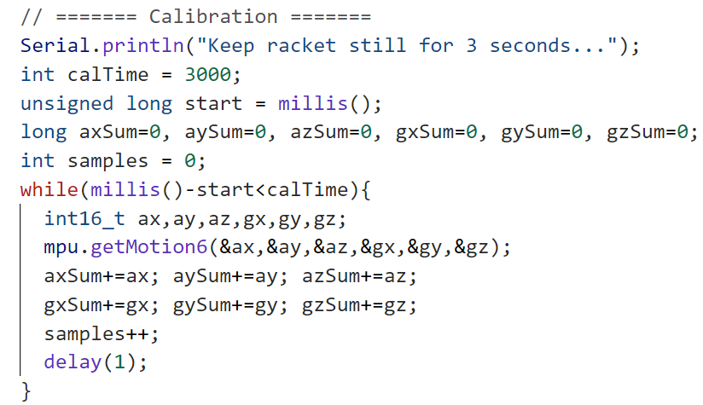
5.3.1 Sensor Calibration – offset values
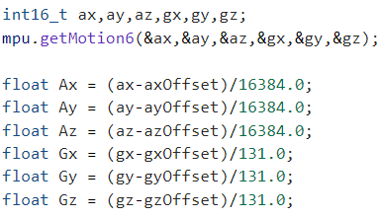
5.3.2 Conversion of raw data into 6 axis motion values

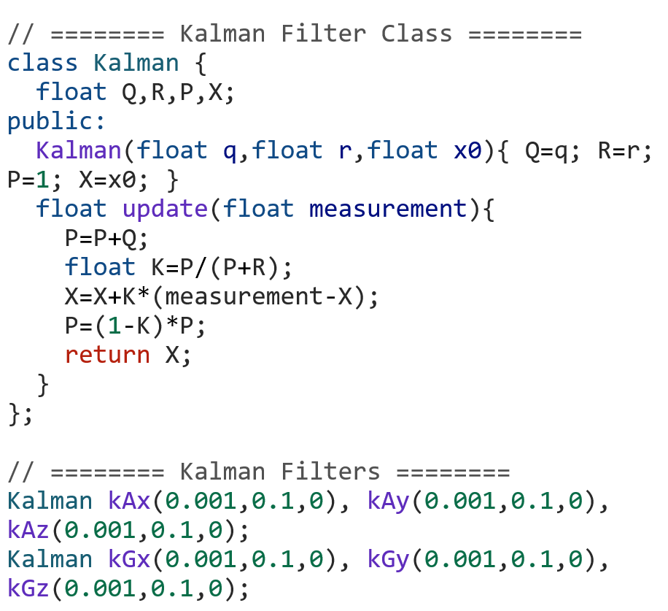
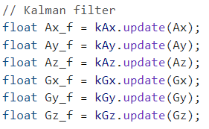
5.3.3 Kalman filter
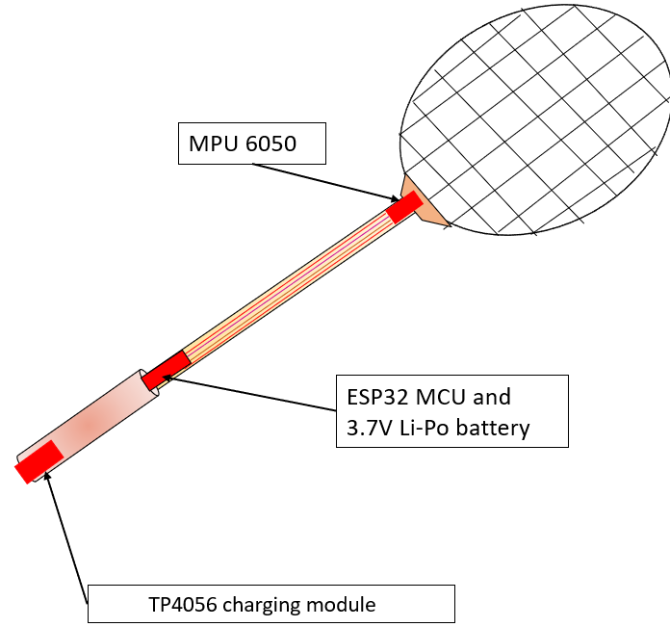
5.4 Design of Prototype

Fig 5.1 Prototype Design
5.6 Hardware Testing and Validation
The assembled circuit was thoroughly tested to ensure correct functionality and stable data transmission. Initial testing involved verifying I²C communication by checking raw accelerometer and gyroscope data through the Arduino serial monitor. Once the communication was confirmed, calibration routines were executed to determine offset values and validate sensor linearity.
Subsequent tests included dynamic motion experiments to ensure that acceleration and rotation readings accurately represented the physical swing of the racket. The hardware successfully maintained consistent performance during repeated tests, proving its reliability under real-world conditions.

CHAPTER 6
RESULTS
The developed smart badminton swing analysis system was tested under real gameplay and controlled swing conditions. The device successfully captured real-time acceleration and angular velocity data from the MPU6050 sensor and transmitted it wirelessly to the web interface hosted through the ESP32 microcontroller. The implemented Kalman Filter effectively reduced noise and drift in sensor measurements, resulting in smoother and more reliable motion curves.
The smash swings consistently showed higher peak acceleration values, indicating greater swing force, while drop shots displayed lower magnitude and smoother motion transitions. These patterns confirmed that the system is capable of differentiating swing styles based solely on motion parameters.
The collected data was stored in CSV format, enabling further offline analysis using MATLAB, Python, and Excel. Graphical visualization of the data clearly demonstrated identifiable swing phases including pre-swing preparation, acceleration phase, impact moment, and follow-through. The real-time monitoring interface provided immediate visual feedback, helping the user to understand performance trends instantly.
The prototype maintained stable wireless connectivity up to an approximate range of 8–10 meters from the host computer. The 3.7V Li-Po battery powered the system efficiently for about 2.5 to 3 hours of active usage, making it suitable for full training sessions. The overall weight added to the badminton racket was minimal and did not significantly affect user comfort or gameplay performance.
These results demonstrate that the proposed system is feasible, functional, and effective for real-time swing analysis, offering valuable feedback for performance improvement in badminton training.
.
CONCLUSION

Summary of Findings
The Badminton Swing Analyzer proved to be a low-cost and efficient motion tracking system capable of providing detailed insights into player performance. Compared to high-end motion capture systems, this prototype achieved competitive accuracy while maintaining portability and affordability.
The combination of MPU6050, ESP32, and Kalman filtering offered an optimized solution for real-time data acquisition and analysis. Although minor latency was observed in wireless data transmission during high-speed swings, it did not affect the overall system functionality.
Long-term usage showed that the setup remained stable and durable, with negligible sensor drift after multiple sessions. The CSV data format simplified post-session analytics and made it compatible with diverse tools such as MATLAB, Excel, and Python libraries like Pandas and Matplotlib.

REFERENCES:

- Rodrigues, João Victor Oliveira, et al. "Performance evaluation of accelerometers ADXL345 and MPU6050 exposed to random vibrational input." Research, Society and Development 10.15 (2021): e286101523082-e286101523082.

- Fedorov, D. S., et al. "Using of measuring system MPU6050 for the determination of the angular velocities and linear accelerations." Automatics & Software Enginery 11.1 (2015): 75-80.

- Jacob, Alvin, Wan Nurshazwani Wan Zakaria, and Mohd Razali Bin Md Tomari. "Implementation of IMU sensor for elbow movement measurement of badminton players." 2016 2nd IEEE International Symposium on Robotics and Manufacturing Automation (ROMA). IEEE, 2016.

- Li, Li, and Feng Li. "Recognizing badminton hitting movements Based on Multi-sensor trajectory recognition algorithm." 2023 3rd International Conference on Information Technology and Contemporary Sports (TCS). IEEE, 2023.

- Manrique, D. Cabello, and J. J. González-Badillo. "Analysis of the characteristics of competitive badminton." British journal of sports medicine 37.1 (2003): 62-66.

